Dashboard component title:
CHWs’ contribution to selected essential health service coverage indicators

Primary dashboard visualization
Group title | Donot chart Label and tooltip | Horizontal bar graph Label and tooltip
Contraceptive Use | Label: Women Using Contraception (%) | Label: Contraceptive Source
Contraceptive Use | Tooltip: % of women who use any contraceptive method | Tooltip: Source of modern contraceptive methods
Antenatal Care (ANC) | Label: Skilled ANC Coverage (%) | Label: ANC Provider
Antenatal Care (ANC) | Tooltip:% receiving antenatal care from a skilled provider | Tooltip: Antenatal care provider
Mother’s First PNC | Label: Mother PNC ≤2 Days (%) | Label: Mother PNC Provider
Mother’s First PNC | Tooltip: % of women with a postnatal check during the first 2 days after birth | Tooltip: Type of health provider of mothers' first postnatal checkup
Newborn First PNC | Label: Newborn PNC ≤2 Days (%) | Label: Newborn PNC Provider
Newborn First PNC | Tooltip: % of births with a postnatal check during the first 2 days after birth | Tooltip: Type of health provider of newborn’s first postnatal check
ARI Care Seeking | Label: ARI Care Seeking (%) | Label: ARI Care Source
ARI Care Seeking | Tooltip: Among children under age 5 with symptoms of ARI, % for whom advice or treatment was sought | Tooltip: Among children with symptoms of ARI for whom advice or treatment was sought from
Fever Care Seeking | Label: Fever Care Seeking (%) | Label: Fever Care Source
Fever Care Seeking | Tooltip: Among children under age 5 with fever, % for whom advice or treatment was sought | Tooltip: Among children with fever for whom advice or treatment was sought from
Diarrhea Care Seeking | Label: Diarrhea Care Seeking (%) | Label: Diarrhea Care Source
Diarrhea Care Seeking | Tooltip:Among children under age 5 with diarrhea, % for whom advice or treatment was sought | Tooltip: Among children with diarrhea for whom advice or treatment was sought from
Households with ITN | Label: ITN Ownership (%) | Label: ITN Source
Households with ITN | Tooltip: % of households owning at least one insecticide-treated net (ITN) | Tooltip: Source of mosquito nets

Tooltips the indicators when you put the cursor on the above the group title, like an indicator definition
Group title | Donut chart tooltip | Horizontal bar graph tooltip
Contraception Use | Percentage of women who use any contraceptive method | Source of modern contraceptive methods
Antenatal care | Percentage receiving antenatal care from a skilled provider | Antenatal care provider
Mother's first postnatal check | Percentage of women with a postnatal check during the first 2 days after birth | Type of health provider of mothers' first postnatal checkup
Newborn's First Postnatal Check | Percentage of births with a postnatal check during the first 2 days after birth | Type of health provider of newborn’s first postnatal check
Advice or treatment for children with ARI | Among children under age 5 with symptoms of ARI, percentage for whom advice or treatment was sought | Among children with symptoms of ARI for whom advice or treatment was sought from
Advice or treatment for children with fever | Among children under age 5 with fever, percentage for whom advice or treatment was sought | Among children with fever for whom advice or treatment was sought from
Advice or treatment for children with diarrhea | Among children under age 5 with diarrhea, percentage for whom advice or treatment was sought | Among children with diarrhea for whom advice or treatment was sought from
Household possession of mosquito nets | Percentage of households owning at least one insecticide-treated net (ITN) | Source of mosquito nets

Community Health program maturity
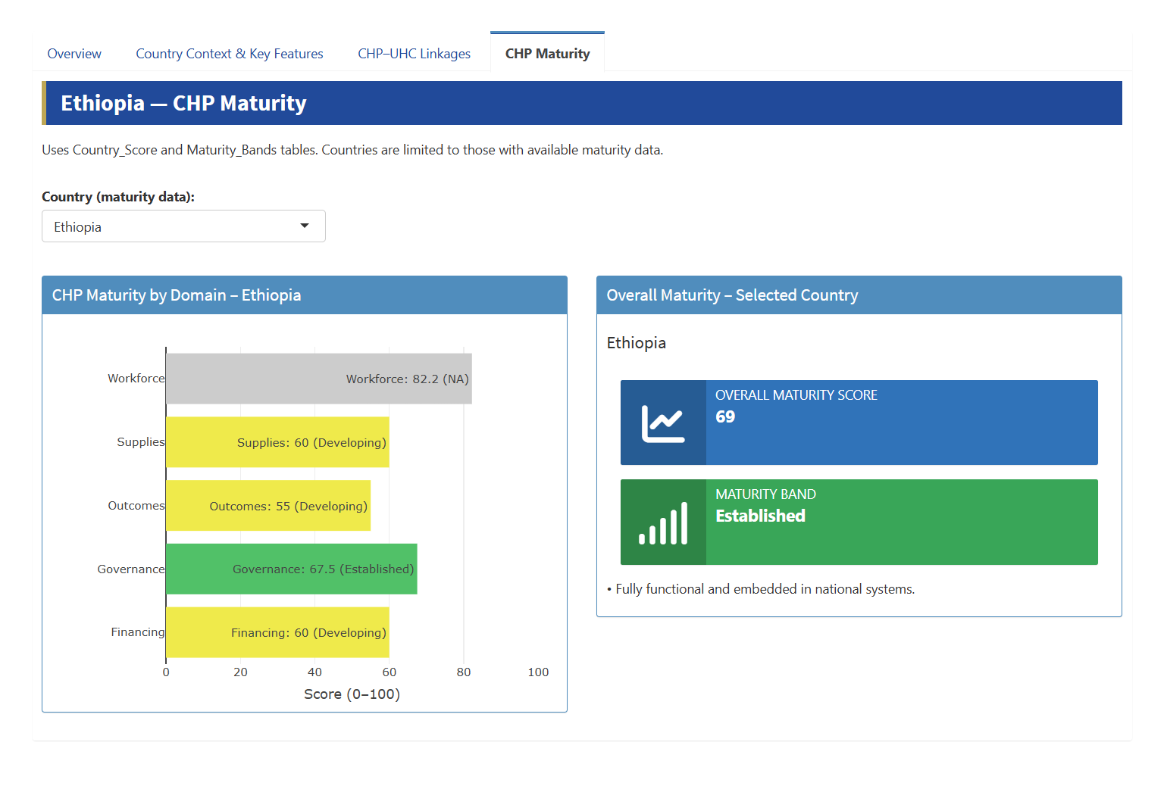
Category | Components
Leadership and Governance | 1. CHP Policy and legal recognition of CHWs with defined roles  2. Multi-sectoral coordination  3. Community health units and engagement structures operational at all levels  4. M&E framework integrated into HMIS and digitized
Financing | 5. Dedicated budget line for CHP within PHC budget
Workforce | 6. Certified CHWs post-standard training  7. Career pathways integrated into PHC and civil service  8. Salaried CHWs integrated into civil service
Supplies | 9. Reliable availability of essential supplies
Outcomes | 10. Universal access to and utilization of essential health services

